Notes Generated by the Agent
Part A
1. Screening note on ethylene capacity in Southeast Asia: the capacity base, recent developments, and what we can’t confirm.
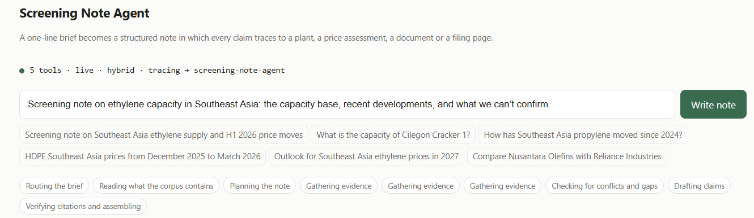
Output:
PLAN:
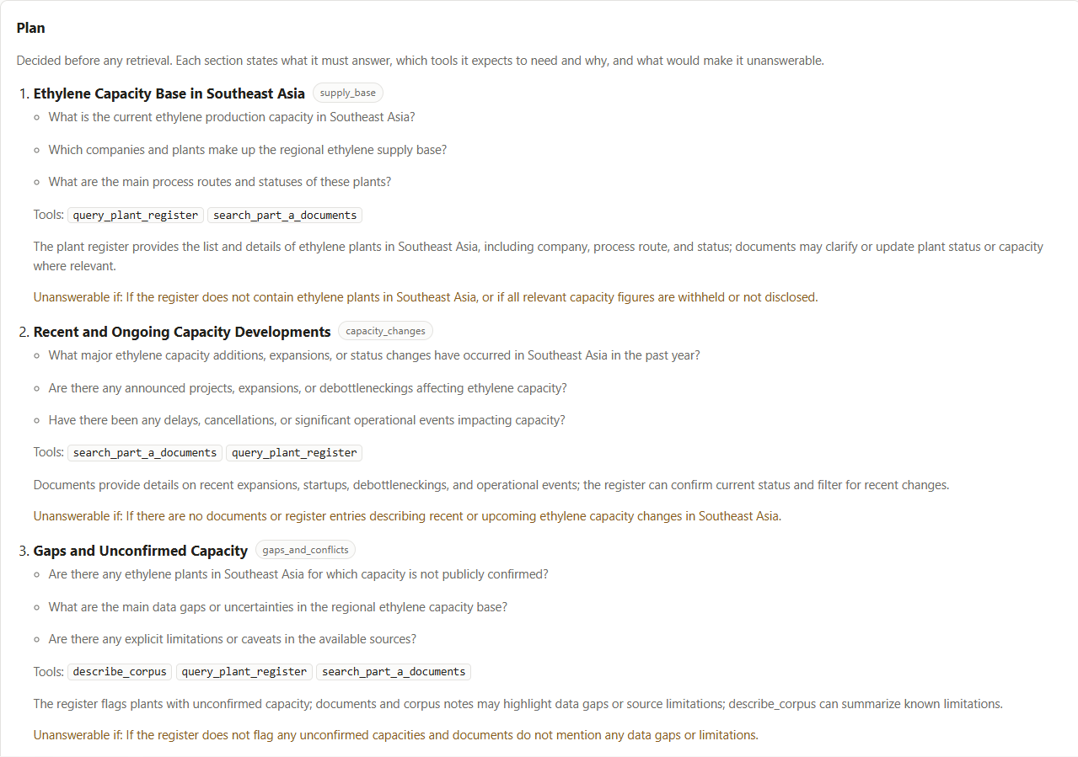
NOTE:
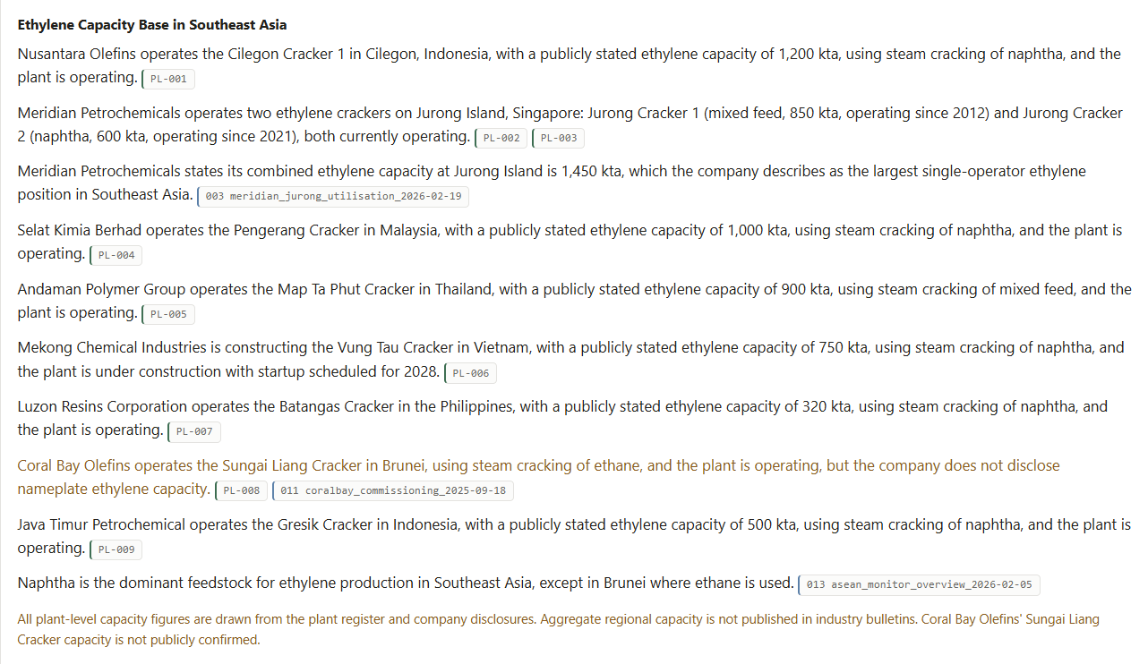
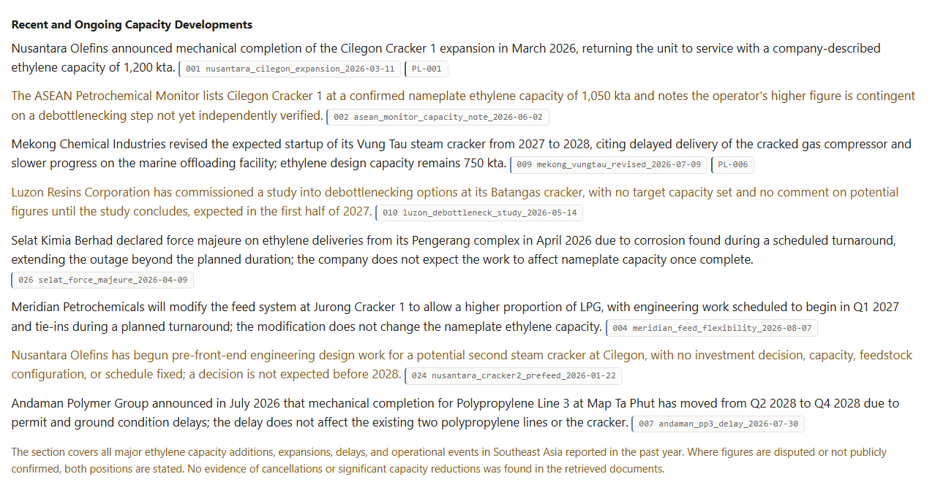
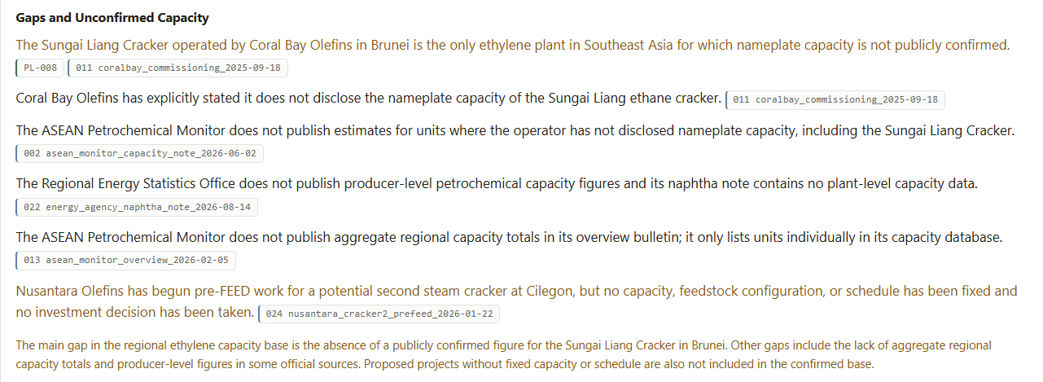
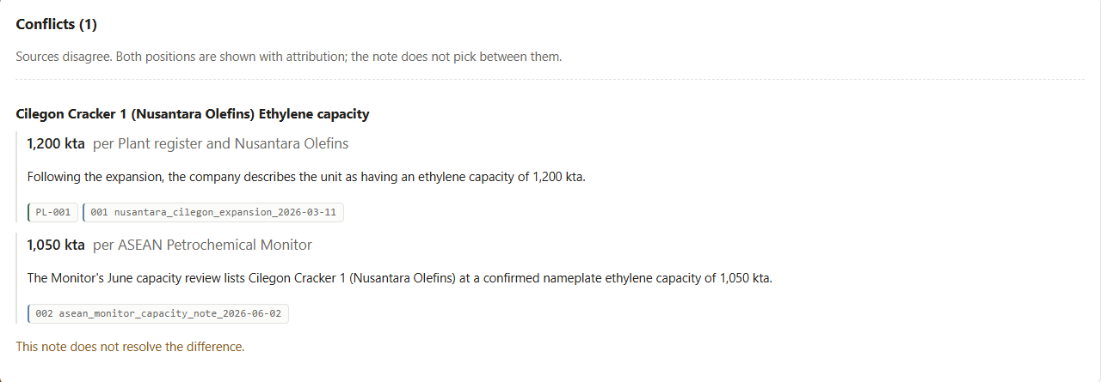
TOOL CALLS:
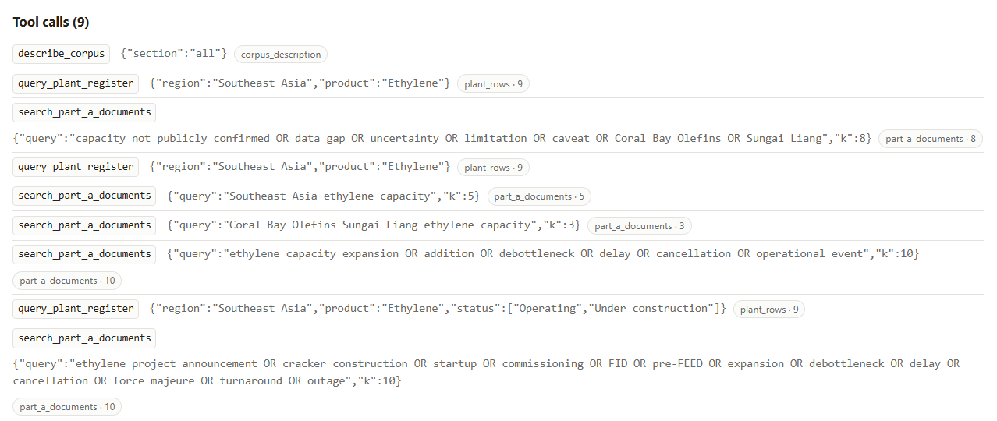

2. Screening note on Andaman Polymer Group’s polypropylene position at Map Ta Phut, including project status.
Output:
PLAN:
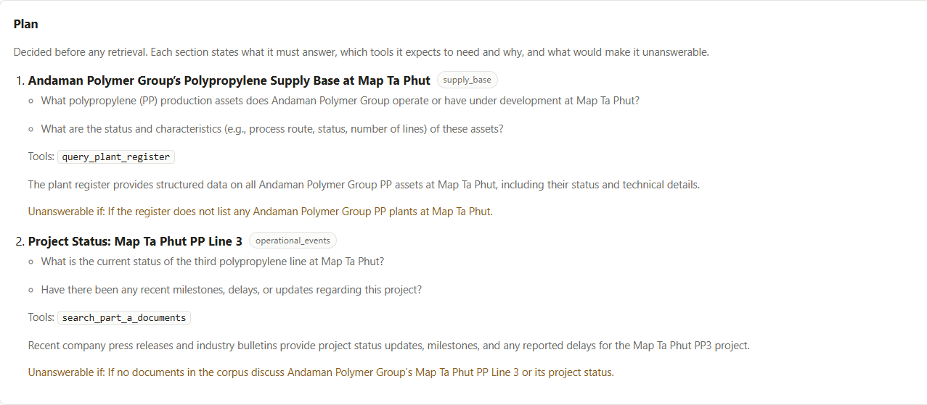
NOTE:
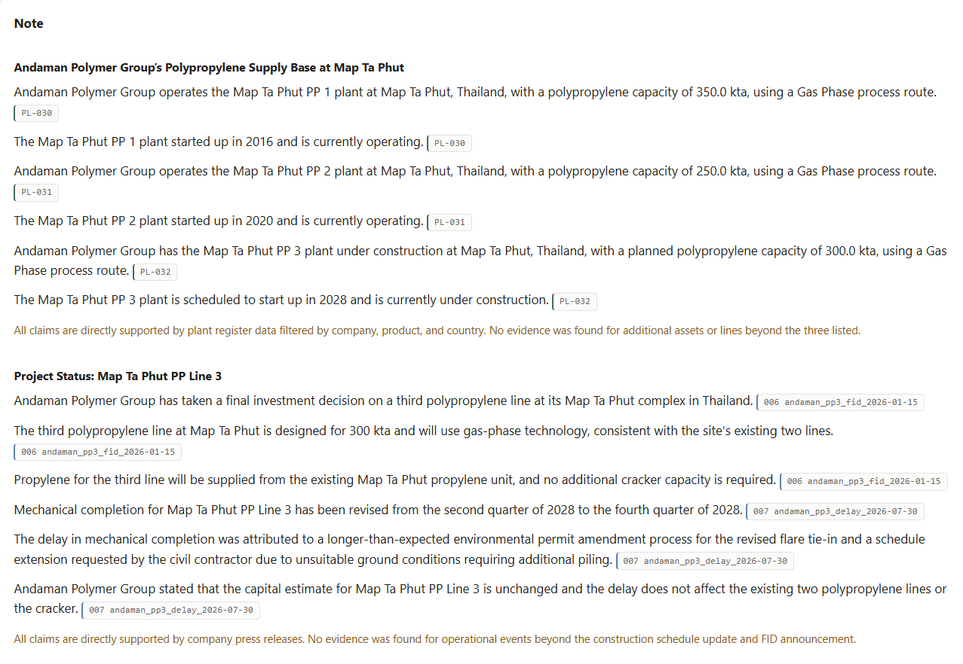
3. Screening note on ethane-based cracking in Southeast Asia.
Output:
PLAN:
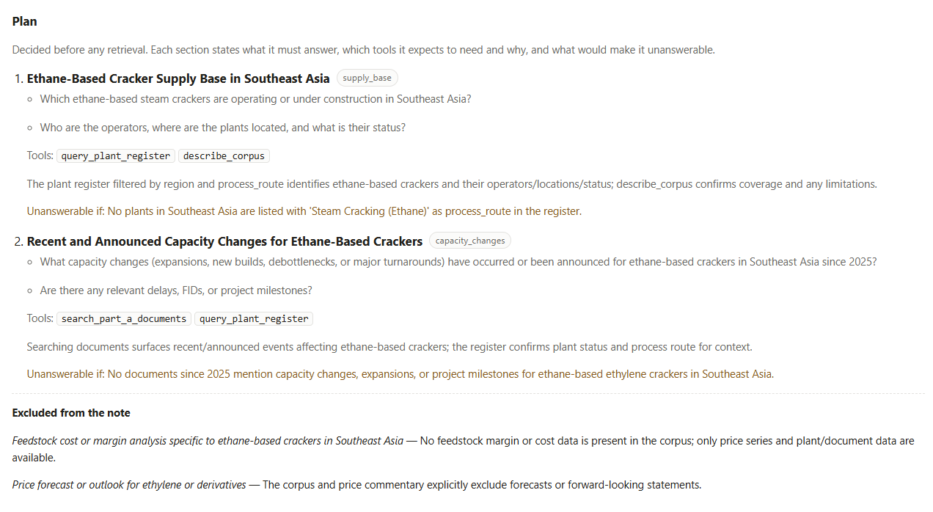
NOTE:
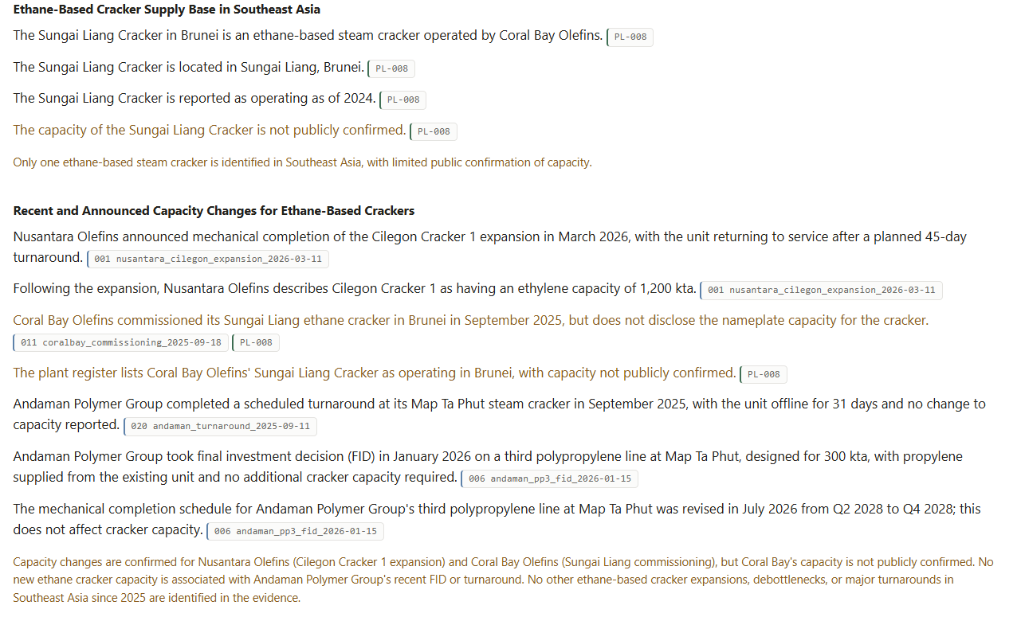
4. Screening note on Southeast Asian ethylene prices: how they moved over the past eighteen months, what drove the moves, and what the outlook is.
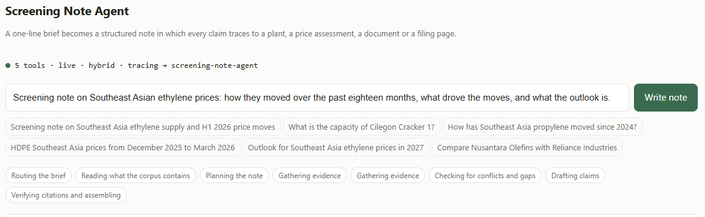
Output:
PLAN:
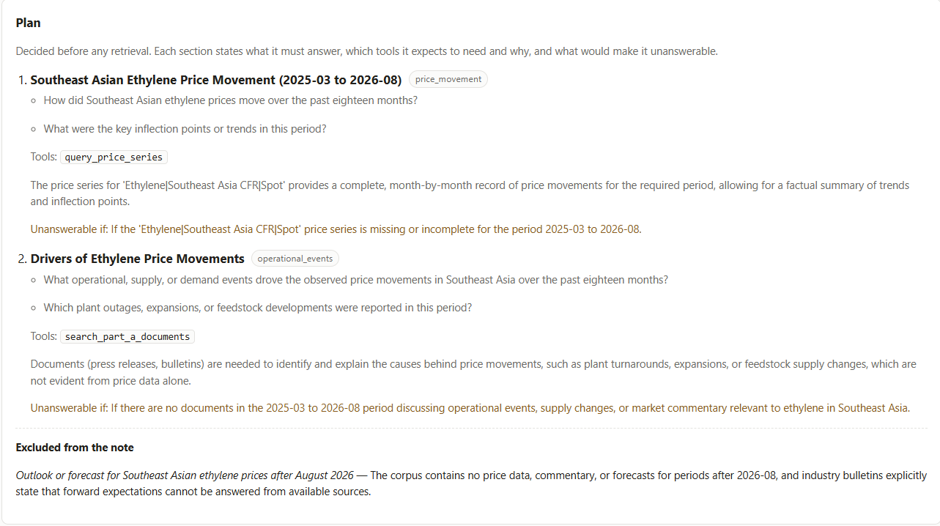
TOOL CALL:
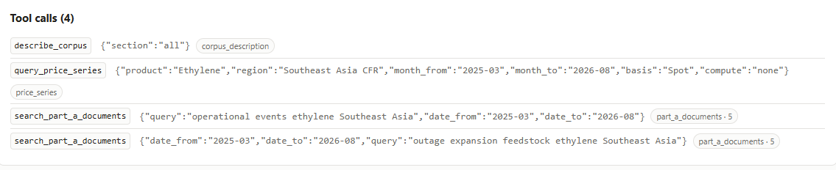
NOTE:
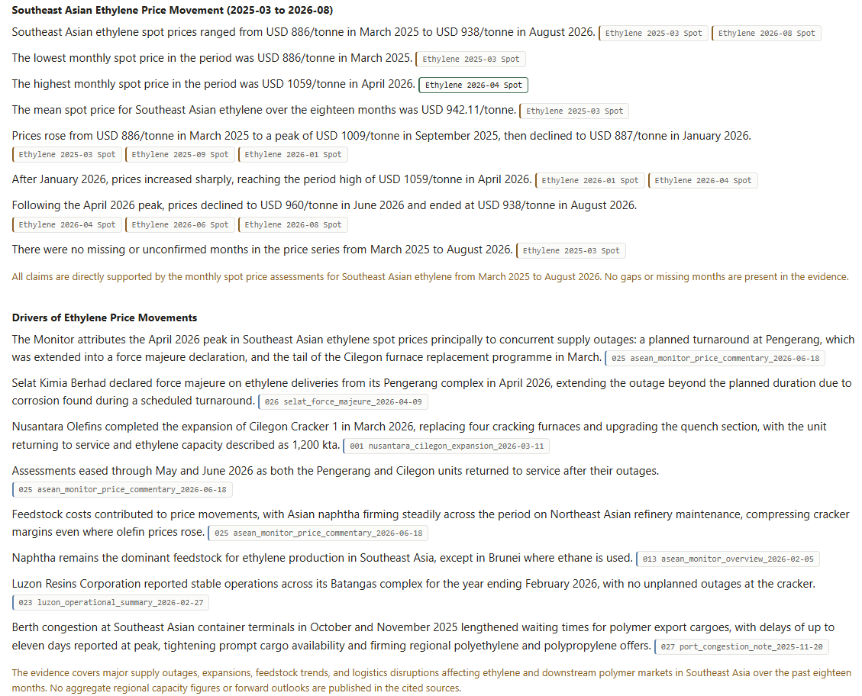
5. Screening note on Southeast Asian polypropylene and HDPE price trends through 2026.
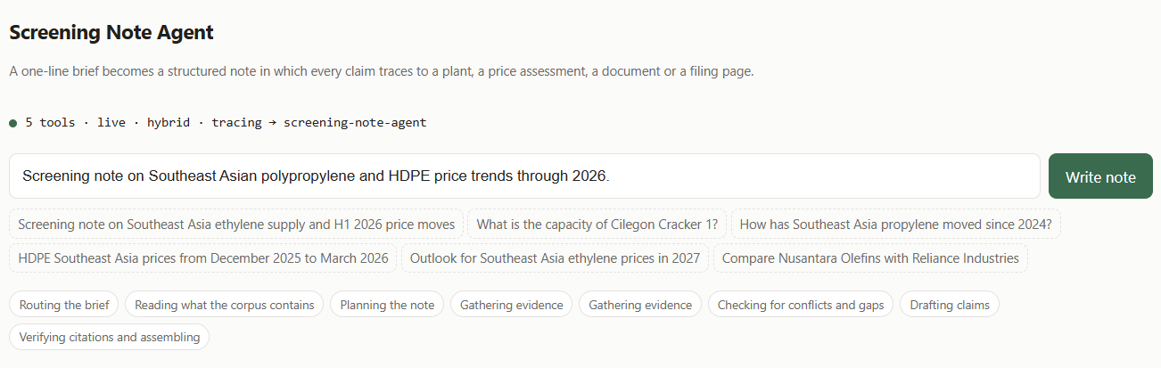

Output:
PLAN:
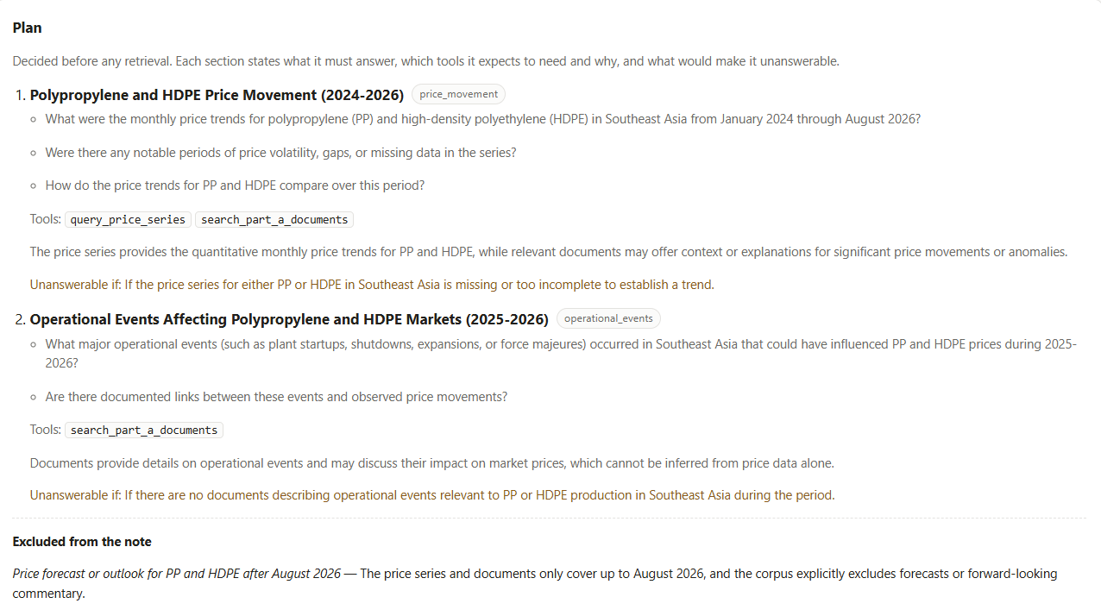

NOTE:

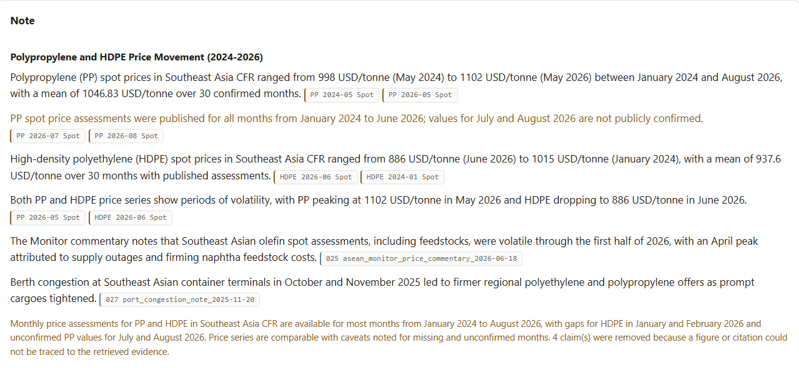
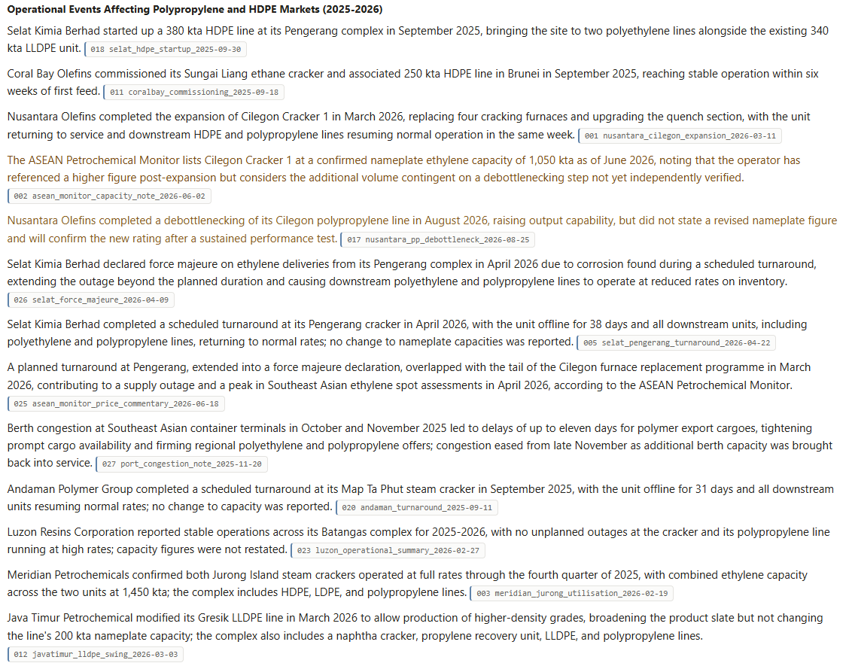
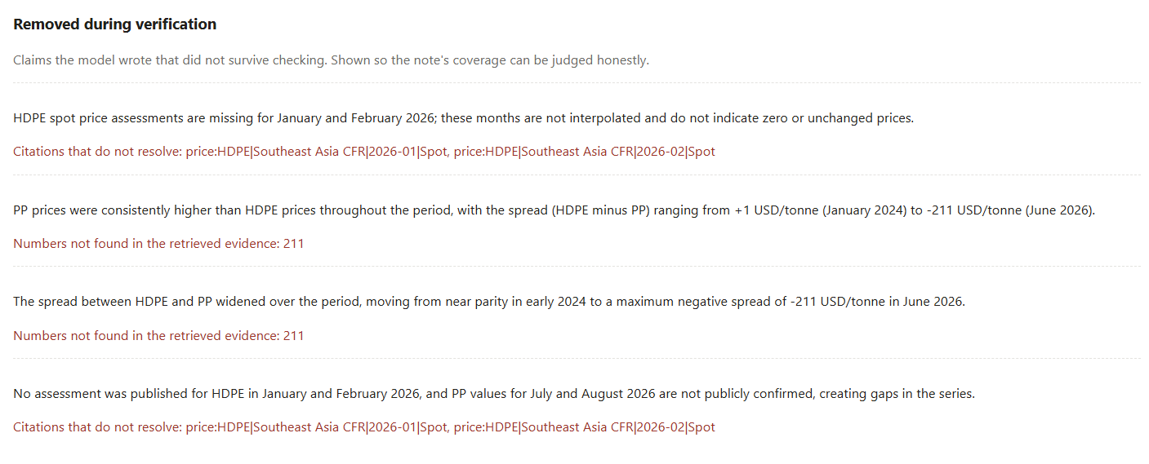
6. Competitor analysis: compare the petrochemical financial performance of GC, PCG and Reliance over their most recent full financial year, with the most recent quarters where available. Cover revenue, earnings, and what each company says about its own outlook.
Output:
PLAN:
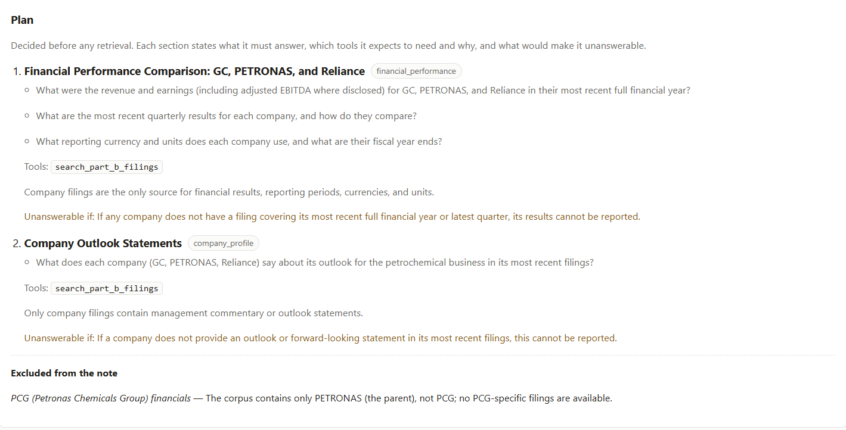
NOTE:
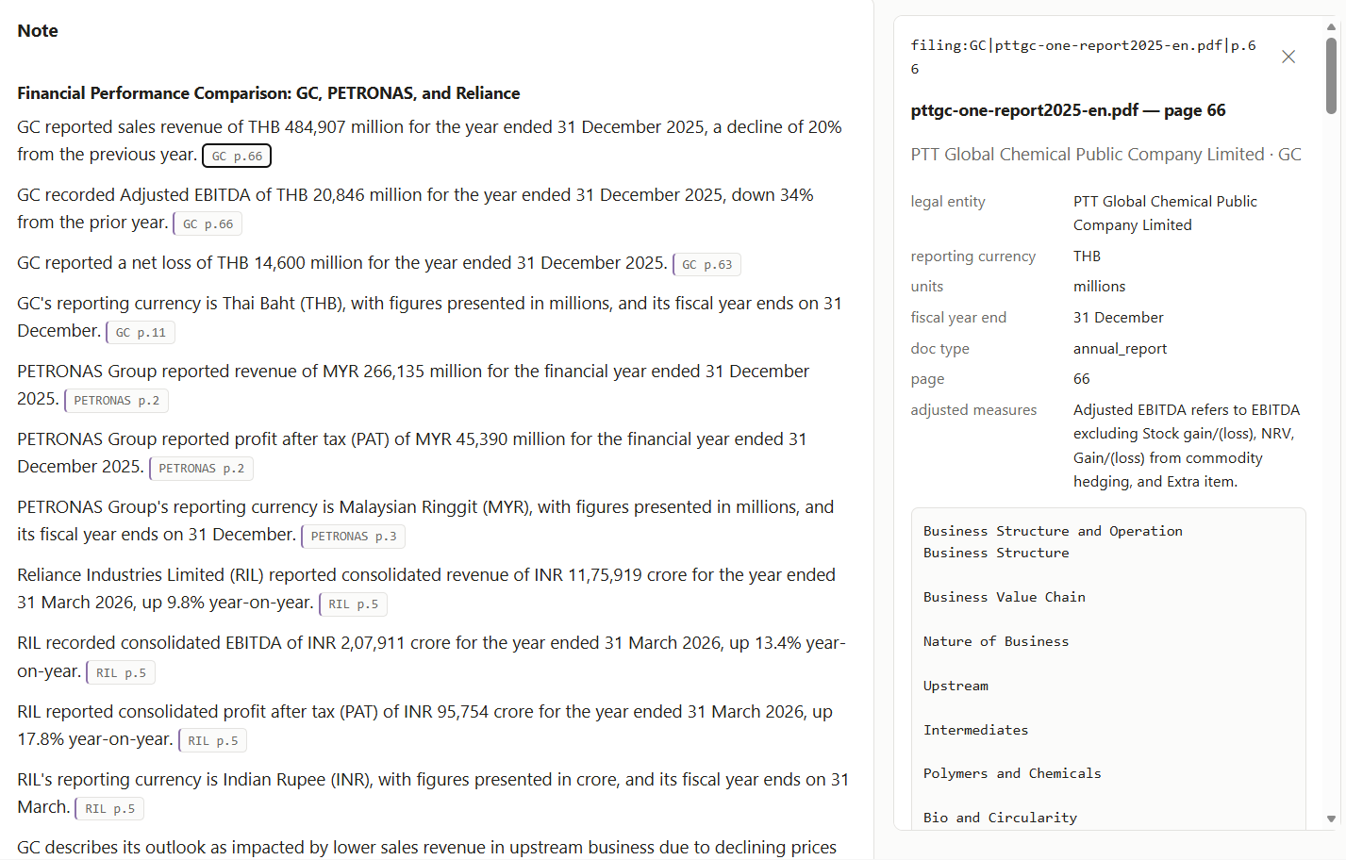
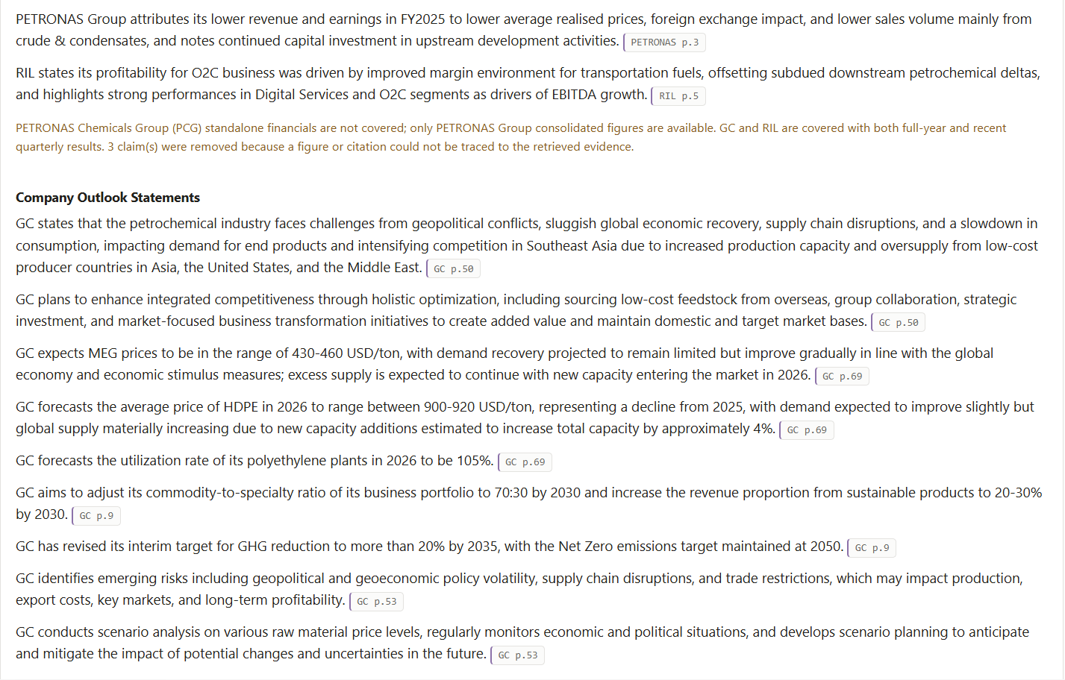
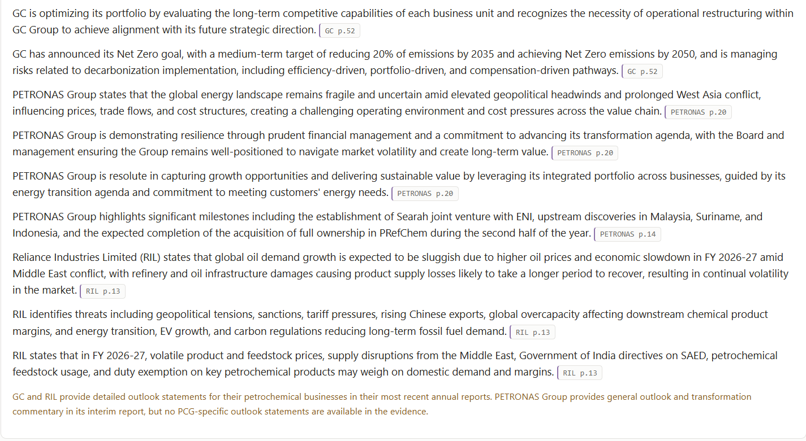
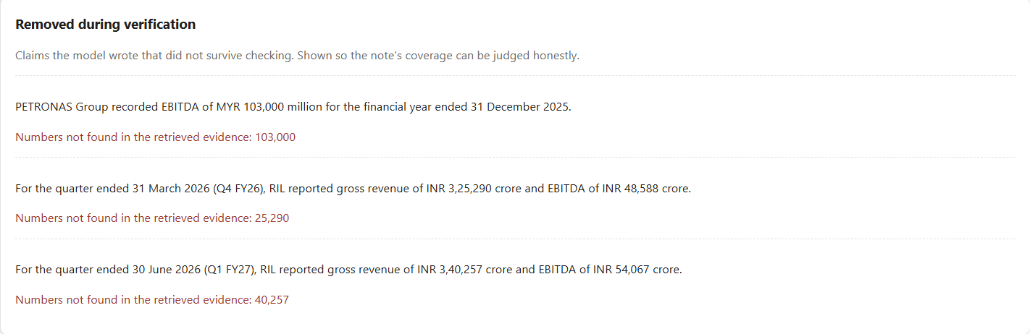
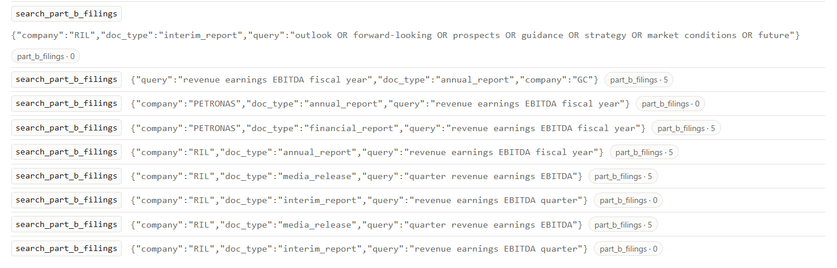
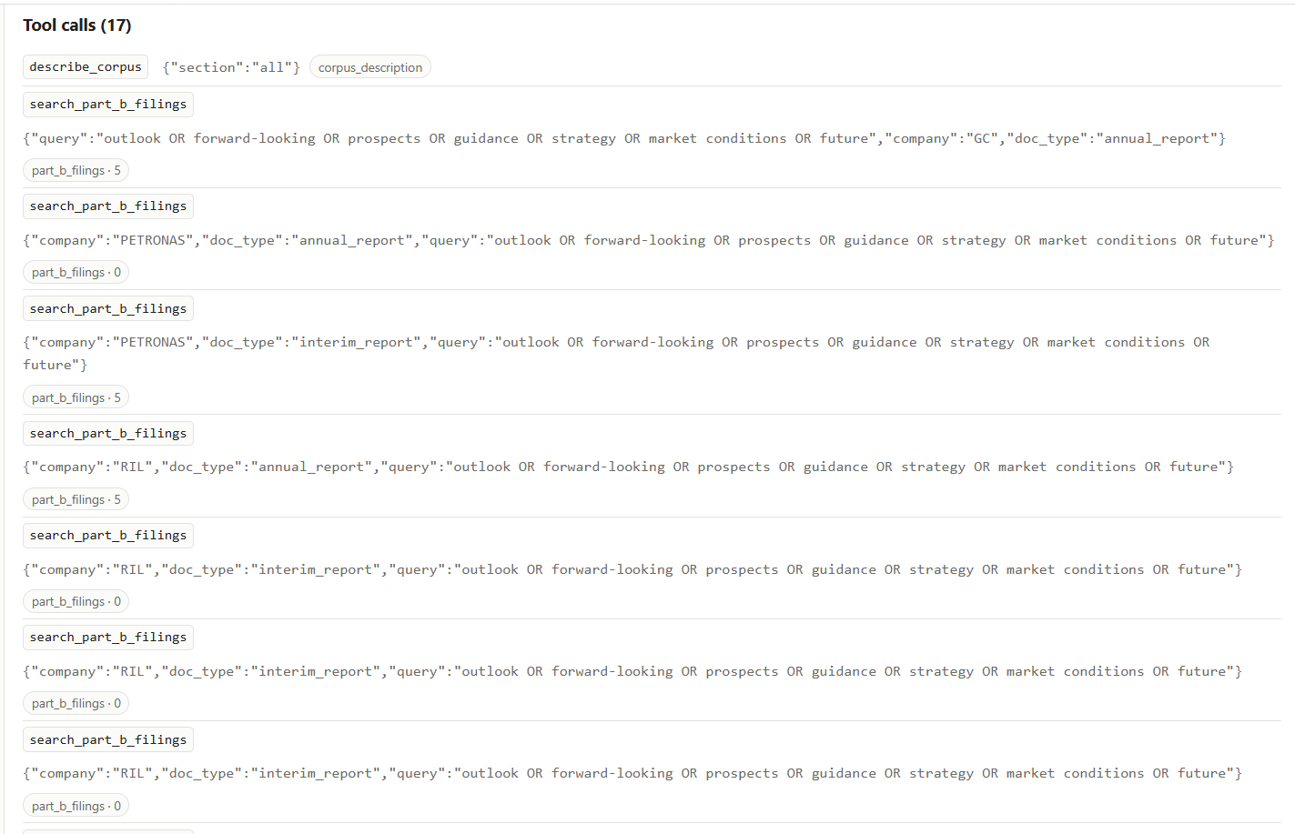
Evaluation Harness and Its Results
Screening Note Agent - evaluation design, what it found, and what it does not cover.
The case suite
11 Part A cases, 5 Part B, 5 refusals. Each case records why it exists, not only what to assert.
Part A - the synthetic register, prices and documents
 | Brief | What it exercises
A01 | SE Asia ethylene supply and H1 2026 price moves | Multi-tool. The series shows what moved; only the documents say why
A02 | How has SE Asia propylene moved since 2024? | Basis break. A single 2024-to-2026 delta is wrong however well cited
A03 | HDPE prices Dec 2025 – Mar 2026 | Two months have no assessment. Must not interpolate
A04 | Latest assessed PP price | Rows exist with blank prices — a different fact from a missing month
A05 | Coral Bay Sungai Liang cracker capacity | Not publicly confirmed. Any number is fabricated
A06 | Cilegon Cracker 1 ethylene capacity | The conflict case. 1,200 kta and 1,050 kta, both attributed
A07 | Vung Tau startup year | Supersession: 2027 revised to 2028
A08 | Total operating SE Asia ethylene capacity | Aggregation discipline: 5,370 kta over 7 of 8 units
A09 | Naphtha–ethylene spread | Region mismatch: Asia CFR against Southeast Asia CFR
A10 | Operational events at Pengerang 2026 | Two interleaved documents, one superseding
A11 | Andaman PP3 schedule | Scoped supersession — the 300 kta capacity stays current
Part B - three real companies' filings
 | Brief | What it exercises
B01 | Reliance Q1 FY2026-27 | Correct currency, units and period
B02 | Compare the Malaysian, Thai and Indian groups over H1 2026 | Three currencies, and Reliance's March year end straddling the window
B03 | How does PTTGC define adjusted EBITDA? | Each company defines it differently; the definition is the fact
B04 | Screening note on PETRONAS Chemicals Group | A gap. No PCG filing exists — the folder holds the parent's filings
B05 | PETRONAS revenue for H1 2026 | A figure that is genuinely present, so the path is not merely refusing
Refusals - where declining is the correct answer
 | Brief | Why it cannot be answered
R01 | Outlook for SE Asia ethylene prices in 2027 | The sources state they publish no forecasts
R02 | Compare Nusantara Olefins with Reliance | The two datasets are never combined in one note
R03 | What did the Cilegon expansion cost? | The company did not disclose it
R04 | Straits Advanced Materials' cracker operations | Straits operates no crackers and is not in the register
R05 | SE Asia capacity against global capacity | No global figure exists anywhere in the corpus

How claims are checked
Structural wherever possible.
Refusals are detected by a structured Refusal object carrying a reason code, not by searching prose for apologetic phrasing. Citations are compared as resolvable tokens, not as texts. A price citation must name product, region, month and basis, so a figure cited on the wrong basis fails even though the month exists. Conflicts are checked by counting attributed positions, and the Conflict model has no resolution field at all, which makes silently picking a side unrepresentable rather than merely discouraged.
Substring checks exist for the few cases where the wording genuinely is the behavior, a note that never says "not publicly confirmed" has not reported the gap, however well structured it is. These are kept to a minimum and always paired with a structural check.
Forbidden figures are the sharpest tool. Case A03 asserts that 922 must not appear anywhere: it is the midpoint a naive interpolation produces across the two HDPE months that have no assessment. If it shows up, the note invented it.
Three assertions were corrected during evaluation
Stated explicitly, because correcting your own tests mid-evaluation deserves scrutiny.
- A07 demanded citations to both the document and the register row. Three runs cited the document alone, which on reflection is right: the press release is the authority for the revision and the register merely agrees. Changed to "at least one of".
- B01 asserted the substring 30, intending "30 June 2026". That matches almost anything and tested nothing. Replaced with the currency and the period.
- B03 required a specific tool, but the corpus-description tool already returns adjusted-measure definitions, so the agent answered correctly in one call instead of two. The assertion was testing an assumption about how to answer rather than whether the answer was right.
No assertion was weakened to make a failing case pass. The remaining failures in the next section are left as failures.
Results
Five live runs. Each fix between runs addressed a defect the harness had surfaced, not an assertion that was inconvenient.
Run | Passed | Failed | Expected failures | What changed before it
1 | 9 | 10 | 2 | first live execution
2 | 12 | 7 | 2 | temporal grounding, tool signatures, non-fatal uncited claims
3 | 14 | 6 | 1 | filter validation, explained empty results, domain-scoped tools
4 | 15 | 5 | 1 | entity resolution against the corpus
5 | 16 | 4 | 1 | aggregate-versus-outside-data boundary

Nine of the twenty-one passed on the first run. The structural machinery worked from the outset: the Cilegon conflict surfaced with both figures attributed, the withheld capacity reported as not publicly confirmed, the blank price values distinguished from missing months, all three refusal cases correct, and the absent PCG filing reported as a gap rather than approximated from the parent.
What failed was almost entirely the agent's ability to reach the evidence — routing, tool arguments, filter values. That split is worth noting: the parts written as deterministic Python held, and the parts left to the model needed the most work.
By the fifth run, six of the seven remaining failed checks were substring assertions. Every structural check - citations resolving, conflicts surfaced with both positions, refusals correct, the two datasets kept apart. Passed.
What the harness found
Four defects, none of which would have been visible without running the agent for real.
An invalid filter became "no evidence exists"
The most serious. The agent searched for the filings with a filename in the slot expecting a document type. The filter matched nothing, the tool returned zero results with no explanation, and the agent concluded:
The question cannot be answered from this corpus. This is a valid finding per the brief's criteria.
For revenue printed on page 2 of the filing it had just been searched.
It reasoned correctly from what the tool told it. The tool lied by omission. This is the no-fabrication policy inverted: instead of inventing a figure it invented a gap, which in a screening note is just as wrong and considerably more plausible-looking.
Fixed three ways. Filter values are validated against reality and rejected with the valid options listed. A real filename filter was added, since the agent wanted to scope to one document and had no legitimate way to say so. And every empty result now carries an explicit note that it does not establish absence.
Over-refusal on historical dates
"H1 2026 price moves" and "December 2025 to March 2026" were both refused as requests for forecasts. Today is September 2026 and the data runs to August 2026, so every month asked for is history. The router had never been told what "now" is, or what period the corpus covers. It silently destroyed two of the most central cases.
The model invented tool arguments
Up to eleven consecutive schema-rejected calls on a single section, exhausting the budget without retrieving anything. The gather prompt described the tools in prose but never showed their parameters, so the model guessed argument names.
A narrower instance of the same fault appeared later: the register and the price series use different region vocabularies, a plant is in "Southeast Asia", a price is assessed at "Southeast Asia CFR" and the tool signatures rendered only region: string (optional), omitting the permitted values that lived in the parameter description.
Real-world knowledge overrode the corpus
"Operational events at Pengerang during 2026" was routed to the real company filings. Pengerang is a genuine PETRONAS site in Johor; in this corpus it is a different operator's plant in the synthetic register. The model routed from memory rather than from the data.
Entity names are now resolved deterministically against the register and the filings before routing, and tool access is scoped to the routed dataset so the other one's tools are hidden entirely.
The three-company H1 2026 comparison was predicted to earn only partial credit, surfacing the currency differences but missing that Reliance's March year end straddles the window. It shipped flagged as a known failure. It passes.
A third prediction was confirmed and turned out worse than expected: the entity-scope ambiguity in the Malaysian filings. All three report the integrated parent, and there is no subsidiary filing in the dataset at all so the correct answer to a brief about it is a gap, not an approximation from the parent's chemicals segment.
What still fails
Four failures and one expected failure, from the fifth run.
A02 — the propylene basis-change caveat does not reliably reach the prose. The tool refuses the cross-basis delta correctly and returns the caveat; the drafter does not always carry it into the note. This case has flipped between passing and failing across runs.
A09 — the region mismatch is emitted but not surfaced. A naphtha-to-ethylene spread joins two different assessment locations. The tool flags it on every call; the note does not always say so. This was predicted before building, and is the prediction that has held.
B01 — a Reliance quarterly summary omitted the currency and the period. Both are available in every retrieved chunk.
B03 and R04 — borderline wording assertions. The substance is present; the specific phrasing the assertion looks for is not always used.
Some of this is variance, not defect
Several cases flipped between runs with no related change, A02 passed on run 2 and failed on runs 3 through 5; B03 failed on a different assertion each time. That is run-to-run variance in the generated prose, and it is currently unquantified. Chasing individual flips would be the wrong response; it needs measuring, which is the gap described next.
The pattern across all five runs is consistent: what varies is wording. What does not vary is the structural layer - the figures, the citations, the conflicts and the refusals are computed in Python and were identical on every run.
Reproducing these results
From backend/:
python -m pytest -q # 234 tests, offline, no credentials
python -m eval.run validate # expectations resolve against the corpus
python -m eval.run list # the 21 cases and what each exercises
python -m eval.run cases # run them (needs credentials)
python -m eval.run cases --id A06 # one case
python -m eval.run repro --n 3 # reproducibility (needs credentials)

Chunking and retrieval
That produced two different designs for the two corpora, because they are different by two orders of magnitude.
Part A is not chunked at all. The 27 documents are 370 to 1,340 bytes each, smaller than a typical chunk, about 20 KB in total. Splitting them would separate the decisive sentence from the front matter naming the speaker, and in this corpus the speaker is half the fact: "1,050 kta" is meaningless without "the Monitor says, and it will carry the lower figure until the debottleneck is verified". So the retrieval unit is the whole document and the tool returns full text. Retrieval is BM25 with metadata filters and deterministic tie-breaking; no embeddings.
Part B is chunked within pages. 2.6 million characters over 505 pages, averaging 5,143 characters a page. Blocks of roughly 800 tokens, split on paragraph then sentence boundaries, with the page as a hard boundary so a citation always resolves to one page. Tables are never split, a table cut in half yields numbers without row labels, or labels without numbers, and either invites a confidently wrong reading.
Only prose is embedded. Tables are reached lexically and by metadata filter. A vector over 152,441 132,563 56,790 carries almost no semantic signal, while the row labels which is how anyone actually finds a figure are exactly what BM25 is good at. Dense retrieval earns its place on the narrative: a brief asking about profitability needs to reach "Profit for the period", with no lexical overlap at all.
The spreadsheets follow the same principle at a third granularity: sheet-level, chunked by row block, with each sheet's header rows repeated into every chunk so a block of figures is never separated from the labels naming them or the period they cover. Citations name the sheet and cell range.
What breaks at 10,000 documents?
The agent's context budget goes first, and it is the one that hurts. Every turn of the gather loop re-sends all evidence collected so far, which is quadratic in tool calls. It is already passing tens of kilobytes per turn on a corpus of 27 documents. This needs evidence summarization, or per-turn scoping to the last result plus a running digest — and that is a redesign of the loop, not a parameter change.
Whole-document retrieval for Part A stops working. 20 KB becomes 7 MB. Chunking becomes mandatory.
The corpus description stops fitting in a prompt. describe_corpus currently returns every enum value, the whole series inventory and the full document list, and the agent leans on it heavily, it is what stops the model guessing filter values. At 10,000 documents it has to become searchable rather than enumerable, which weakens the mechanism that fixed several of the worst failures.
Retrieval infrastructure. In-memory BM25 rebuilt at load, and Chroma with exact search, are both fine at this scale and neither is at 10,000 documents and perhaps 100,000 chunks. That is a move to a real index.
Conflict detection degrades in precision, not in speed. The detector links a capacity figure to a plant by looking for the plant name in the sentence, then falling back to the nearest product word. That works because the corpus is small and clean, and I tuned it by looking at all 17 capacity mentions. At scale it will produce false conflicts, and a section full of spurious disagreements trains the reader to skip it which is worse than not having the section.
Two more weeks
1. Implement the repair loop that the architecture claims exist. Today a claim that fails verification is dropped and the section reports reduced coverage. The design says one targeted re-draft attempt with the failure reason fed back. Dropping is safe but lossy, and several sections came back thinner than the evidence supported.
2. Narrow evidence scope at draft time. The drafter currently sees everything gathered for its section. Passing only the evidence relevant to each claim would tighten provenance and reduce the context pressure described above.
3. Persist runs. They are in memory and lost on restart. Cheap, and the last thing I would do.
What I would deliberately not do in those two weeks: add more tools, integrate ragas, or improve the prose. The first two add surface without adding correctness, and the third is the least broken part.

